 **Assignment Cover Sheet**

Assignment No.: _____

|  |  |  |
| --- | --- | --- |
| **Student Information (For group assignment, please state names of all members)** | | **Grade/Marks** |
| **Name** | **ID** |  |
| Ni Wayan Ratih Suarningsih | E2000435 |  |
|  |  |  |
|  |  |  |
|  |  |  |
|  |  |  |

|  |  |  |
| --- | --- | --- |
| **Module/Subject Information** | | **Office Acknowledgement** |
| **Module/Subject Code** | BIT306 |  |
| **Module/Subject Name** | Software Engineering Principles |  |
| **Lecturer/Tutor/Facilitator** | Mr. Koon Kim Peh |  |
| **Due Date** | 08 December 2023 |  |
| **Assignment Title/Topic** | Assignment 1 |  |
| **Intake (where applicable)** |  |  |
| **Word Count** | n/a | **Date/Time** |

**Declaration**

* I/We have read and understood the Programme Handbook that explains on **plagiarism**, and I/we testify that, unless otherwise acknowledged, the work submitted herein is entirely my/our own.
* I/We declare that no part of this assignment has been written for me/us by any other person(s) except where such collaboration has been authorized by the lecturer concerned.
* I/We authorize the University to test any work submitted by me/us, using text comparison software, for instances of plagiarism. I/We understand this will involve the University or its contractors copying my/our work and storing it on a database to be used in future to test work submitted by others.

Note: 1) The attachment of this statement on any electronically submitted assignments will be deemed to have the same authority as a signed statement.

2) The Group Leader signs the declaration on behalf of all members.

|  |  |
| --- | --- |
| Signature: | Date: |
| E-mail: |  |

|  |
| --- |
| **Feedback/Comments\*** |
| **Main Strengths** |
|  |
|  |
|  |
|  |
|  |
|  |
| **Main Weaknesses** |
|  |
|  |
|  |
|  |
|  |
|  |
| **Suggestions for improvement** |
|  |
|  |
|  |
|  |
|  |
|  |

|  |  |
| --- | --- |
|  | **Student acknowledge feedback/comments** |
|  |
| Grader’s signature | Student’s signature: |
| Date: | Date: |

Note:

1. A soft and hard copy of the assignment shall be submitted.
2. The signed copy of the assignment cover sheet shall be retained by the marker.
3. If the Turnitin report is required, students have to submit it with the assignment. However, departments may allow students up to **THREE** (3) working days after submission of the assignment to submit the Turnitin report. The assignment shall only be marked upon the submission of the Turnitin report.

Contents

Promo Tourism Website 2

1. Screenshot of the landing page 2

2. Screenshot of login page 3

3. Screenshot of merchant dashboard 4

4. Screenshot of Manage Tourism Product 5

5. Screenshot of Merchant Analytics Report 6

6. Screenshot of Officer Dashboard 6

7. Screenshot of Review Merchant Registration 7

8. Screenshot of Officer Analytics Report 8

9. Screenshot of Customer Dashboard 9

10. Screenshot of Purchase Page 10

11. Screenshot of Review Page 12

12. Screenshot of Gallery Page 13

13. Screenshot of register merchant page 14

# Promo Tourism Website

## Screenshot of the landing page

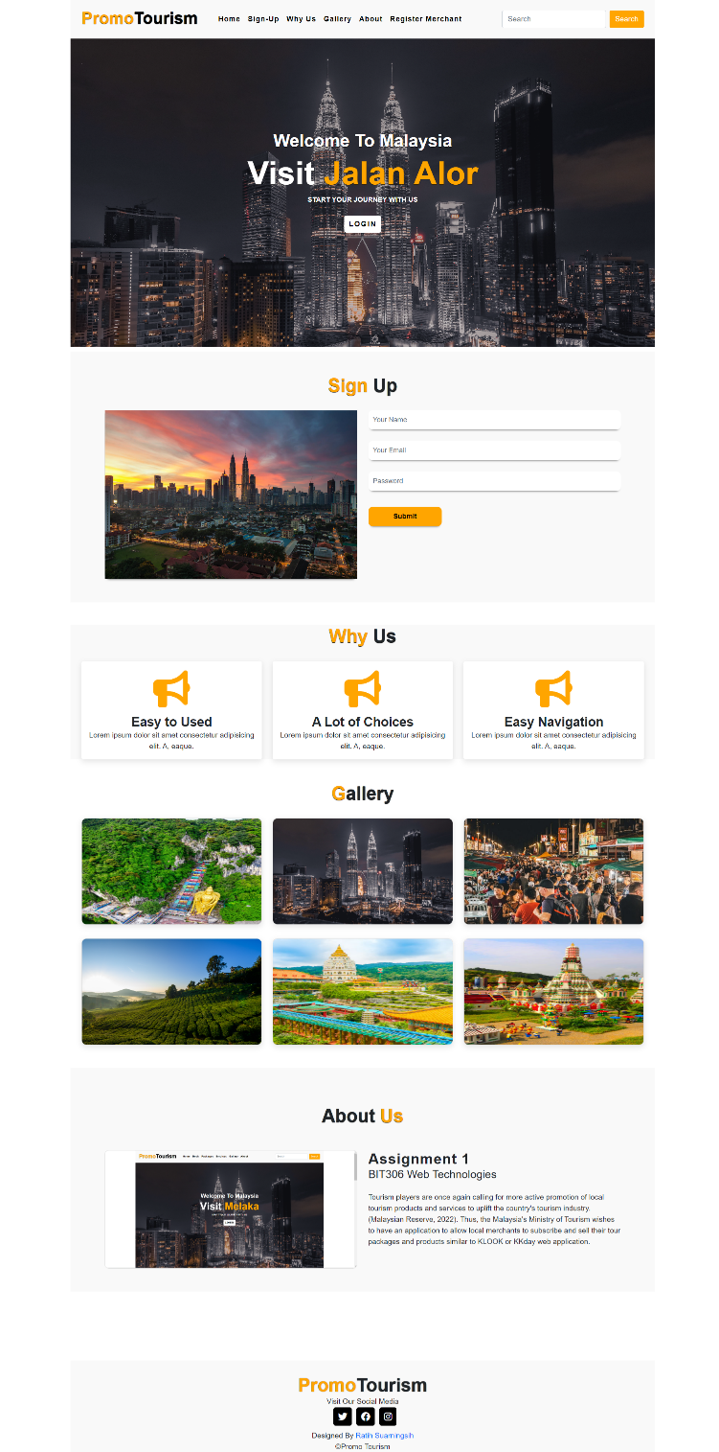

This landing page is the initial display of the Tourism Promo website that I created, where this page contains some content. First there is the welcome section, followed by the registration section, Why us, Gallery, About Us, and finally the footer section. The buttons on the navbar will function to direct users to existing sections. In the welcome section, there is also a login button which can then direct users to the login page if they already have an account.

## Screenshot of login page

In this second image, there is a login page, where in this section I can only connect the login page to the merchant dashboard. With login data, namely username: merchant, and password: merchantpass. In the navbar, there is a home button that connects to the landing page and a gallery button that can connect the user to a collection of existing images

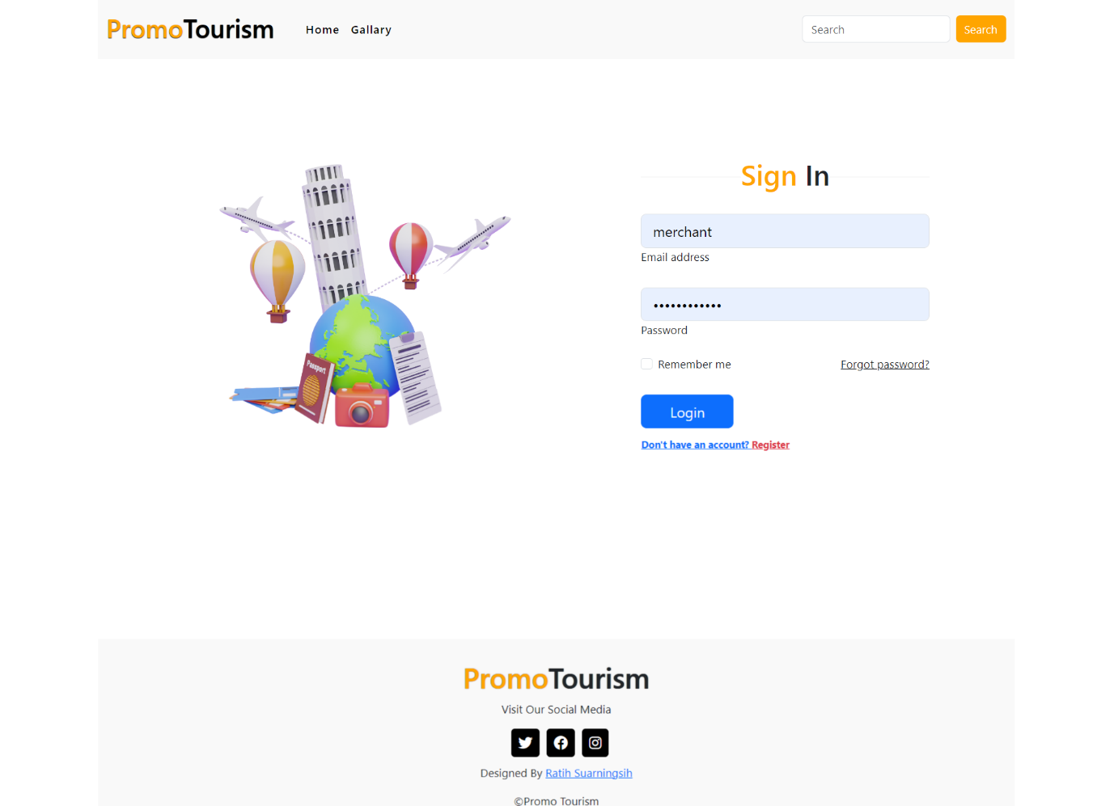

## Screenshot of merchant dashboard

The merchant dashboard can be accessed after logging in. On this page, there is a button that can connect the merchant to the manage tourism product page and merchant analytics report.

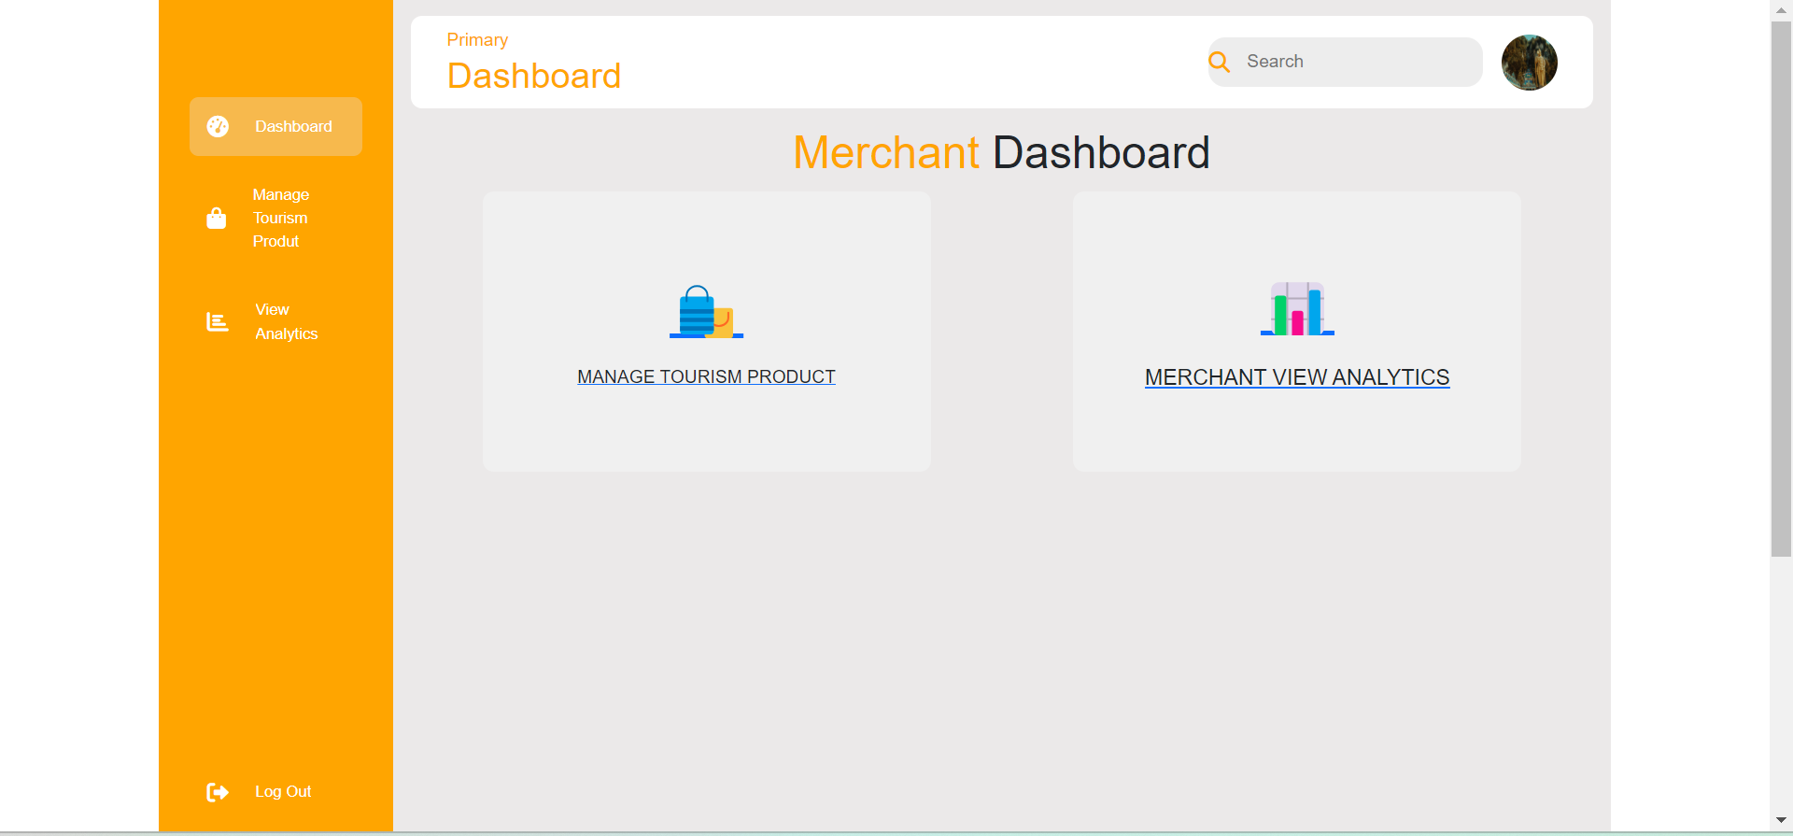

## Screenshot of Manage Tourism Product

Manage tourism product pages consist of several pages that can be managed by merchants, on this page merchants can edit, delete, and add products

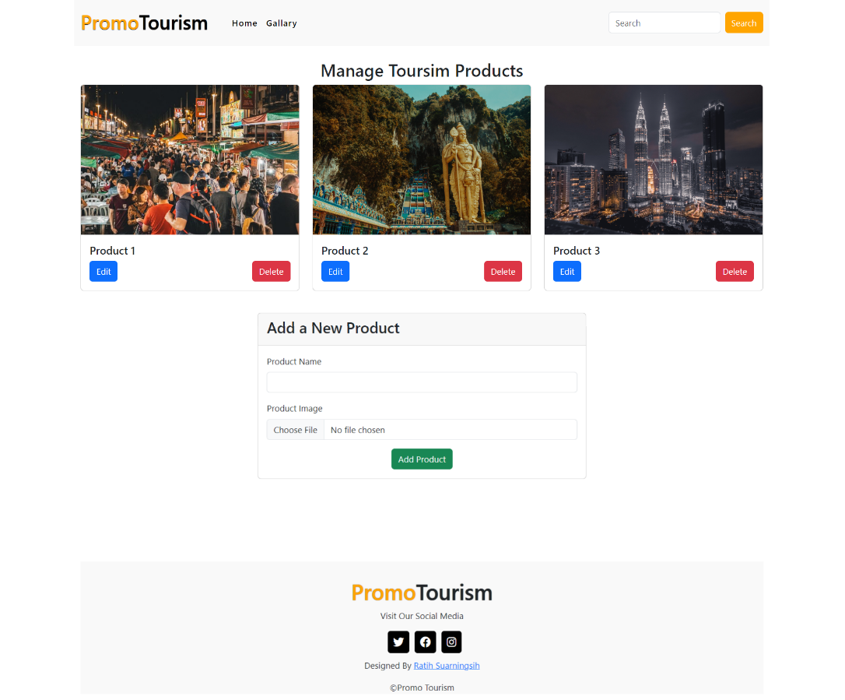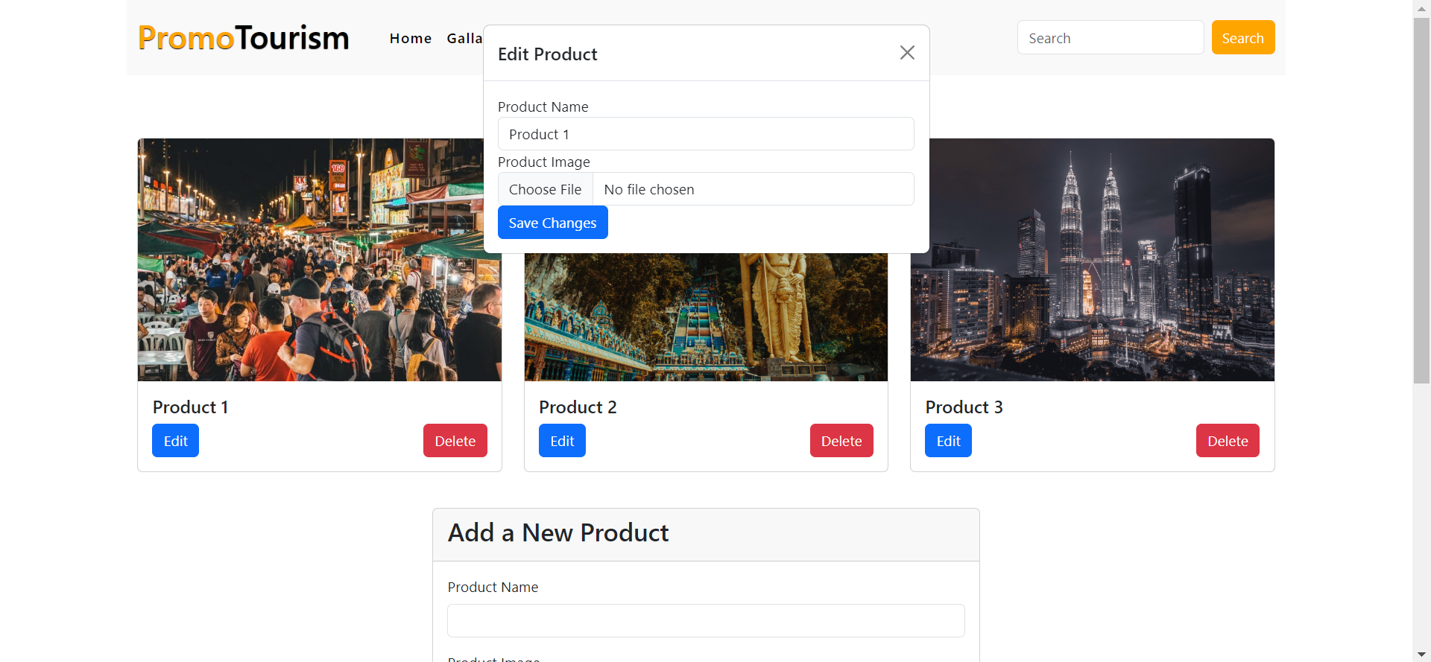

## Screenshot of Merchant Analytics Report

This page allows merchants to view analytical reports for the products they own, with dropdown options to select products. There are two graphs that can display sales and customer data for selected products.

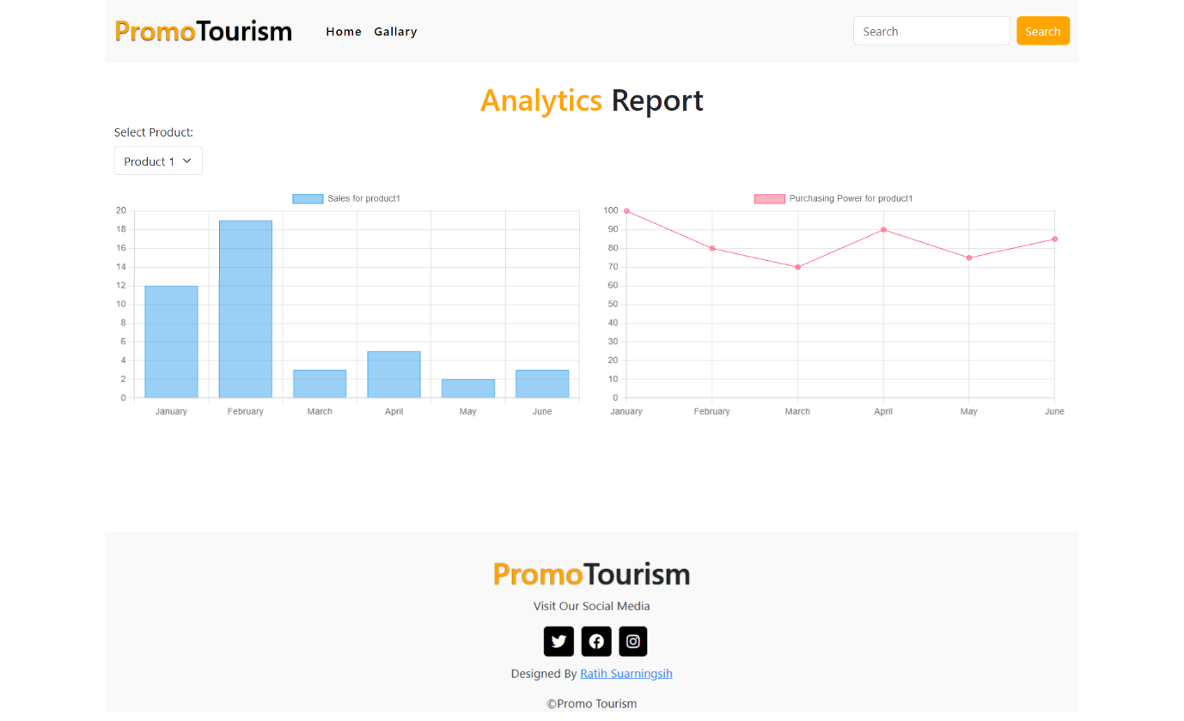

## Screenshot of Officer Dashboard

This page allows officers to see the dashboard, where there is a card button that directs officers to the merchant registration review page and the officer's analysis report page

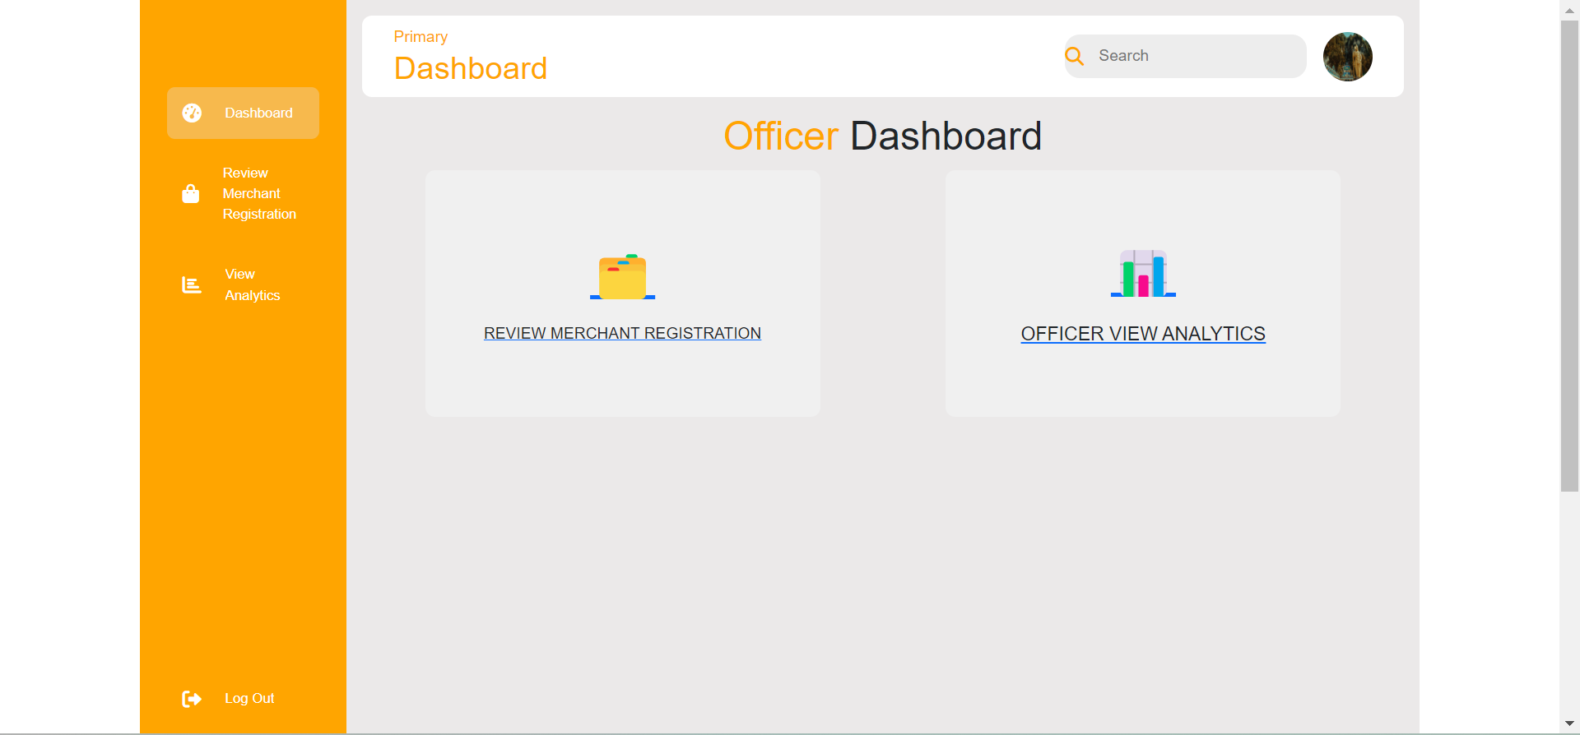

## Screenshot of Review Merchant Registration

On the merchant registration review page, officers can manage the entire list of pending merchants, officers can review merchant details and are able to approve or reject existing pending lists. If the officer is rejected, the officer must provide a reason why the trader was rejected. After the rejection process is complete, the notification "Message has been sent" will appear.

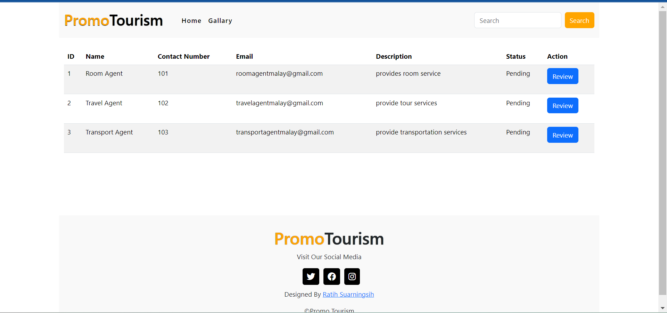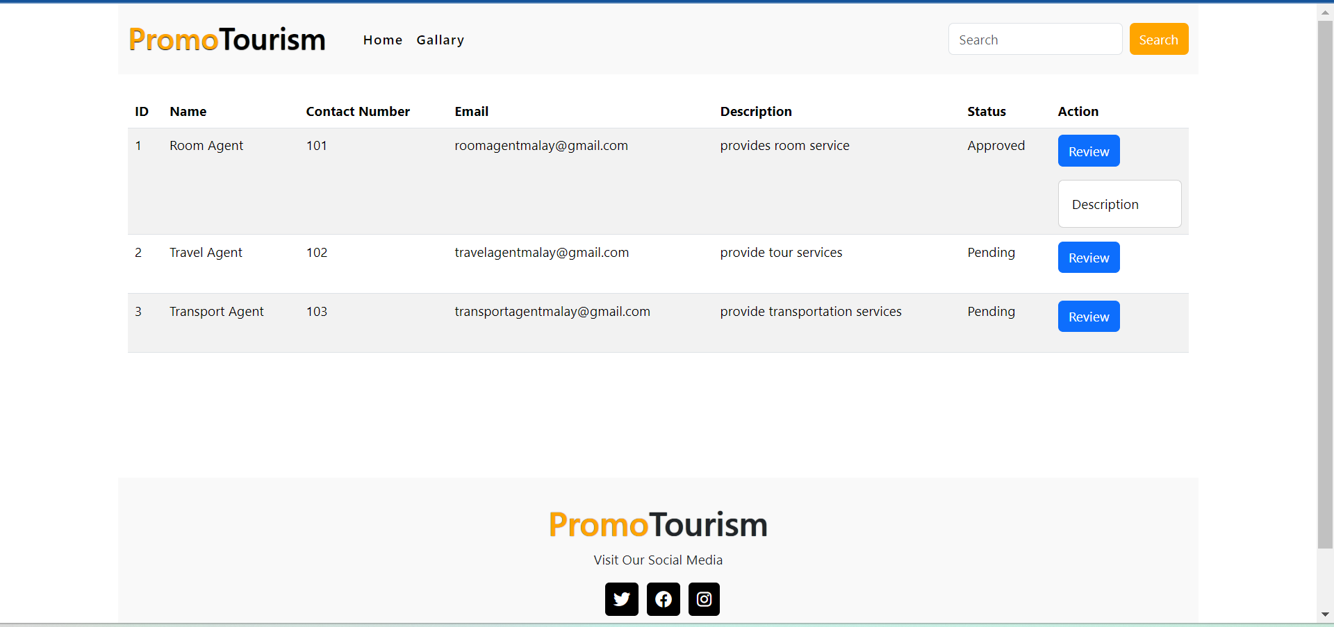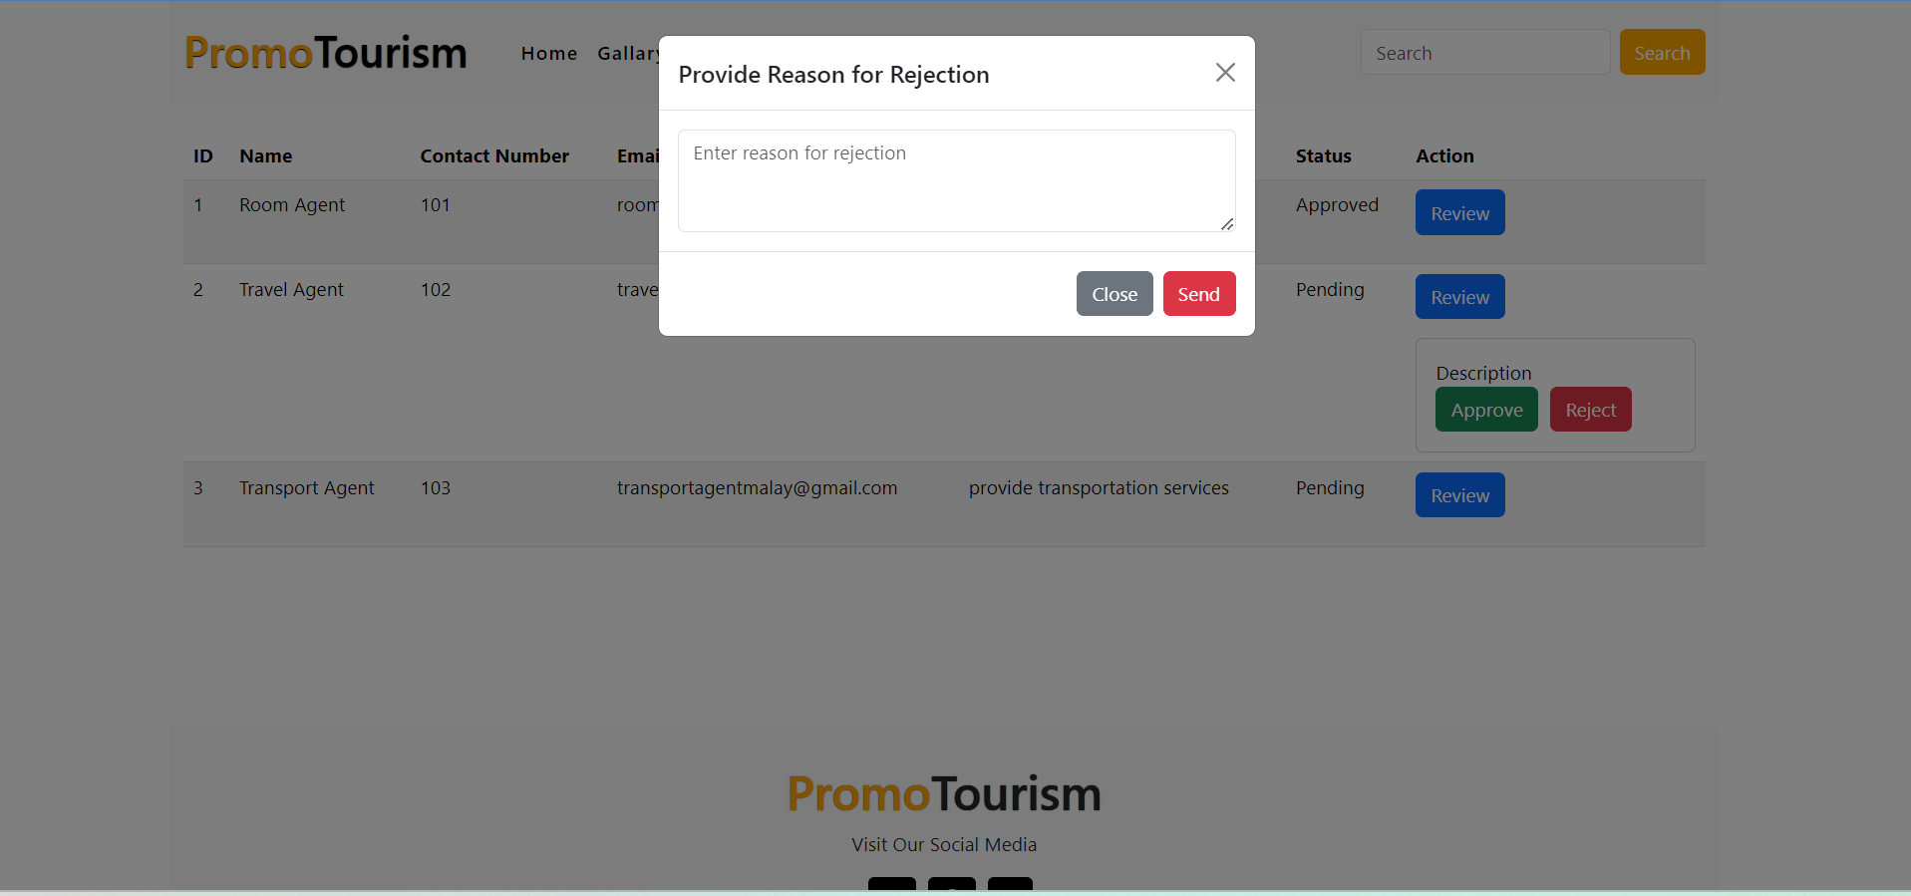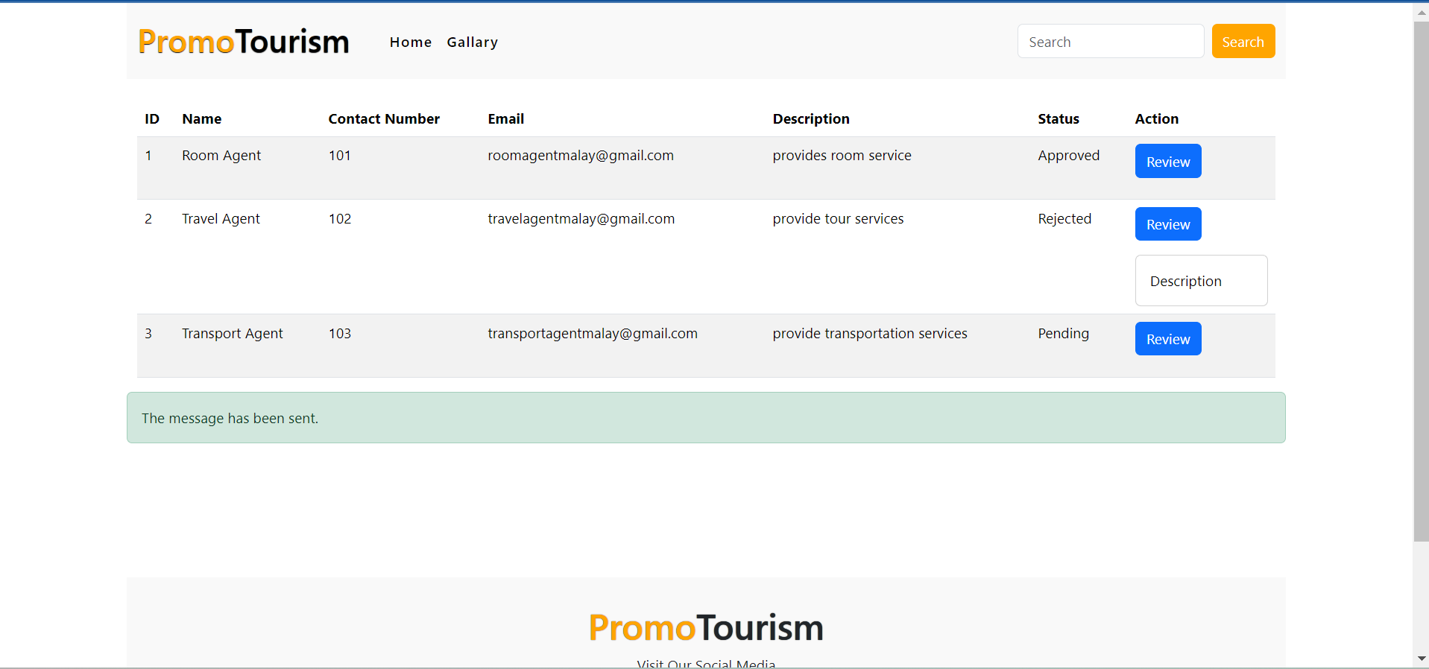

## Screenshot of Officer Analytics Report

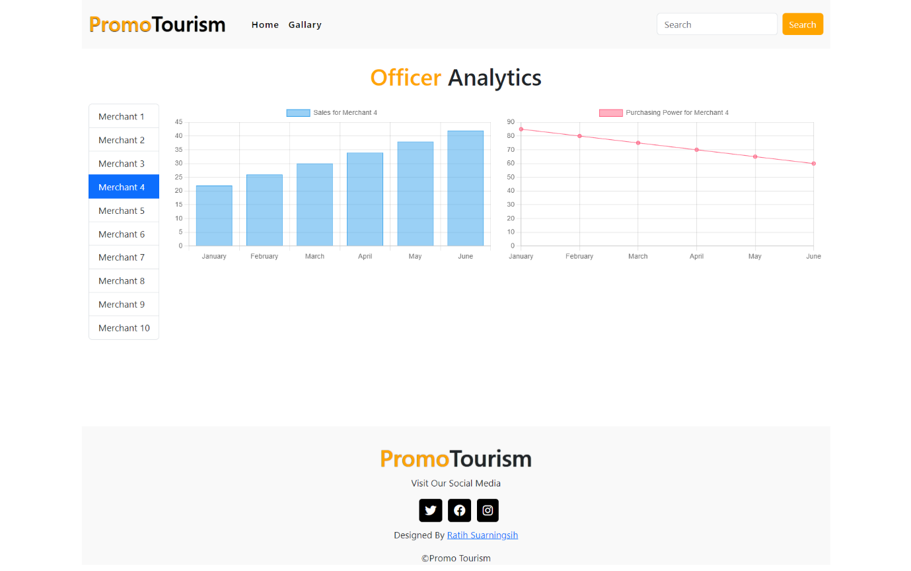On this page, officers can see sales analytics from all merchants through the existing filters, then on the graph on the right there is also the purchasing power of each merchant.

## Screenshot of Customer Dashboard

The customer dashboard page is the first page that appears when a customer logs in to their account. On this page there are 2 buttons that can direct customers to the Purchase page and the Review page.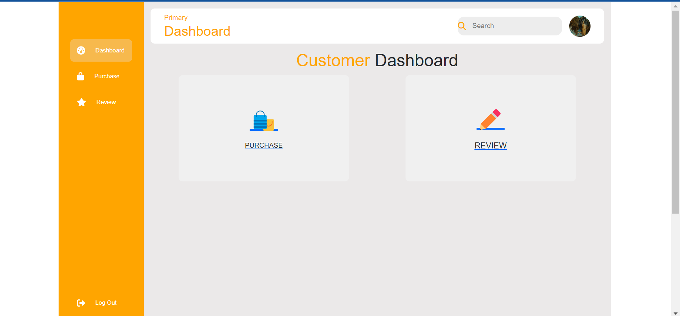

## Screenshot of Purchase Page

On the purchase page, customers can make purchases by clicking the add to cart button, then clicking the cart button, after clicking the cart button the product details will appear and will be directed to the payment modal, after entering the payment modal the customer is directed to fill in the details of the payment made. After successful payment, the system will display a capital receipt

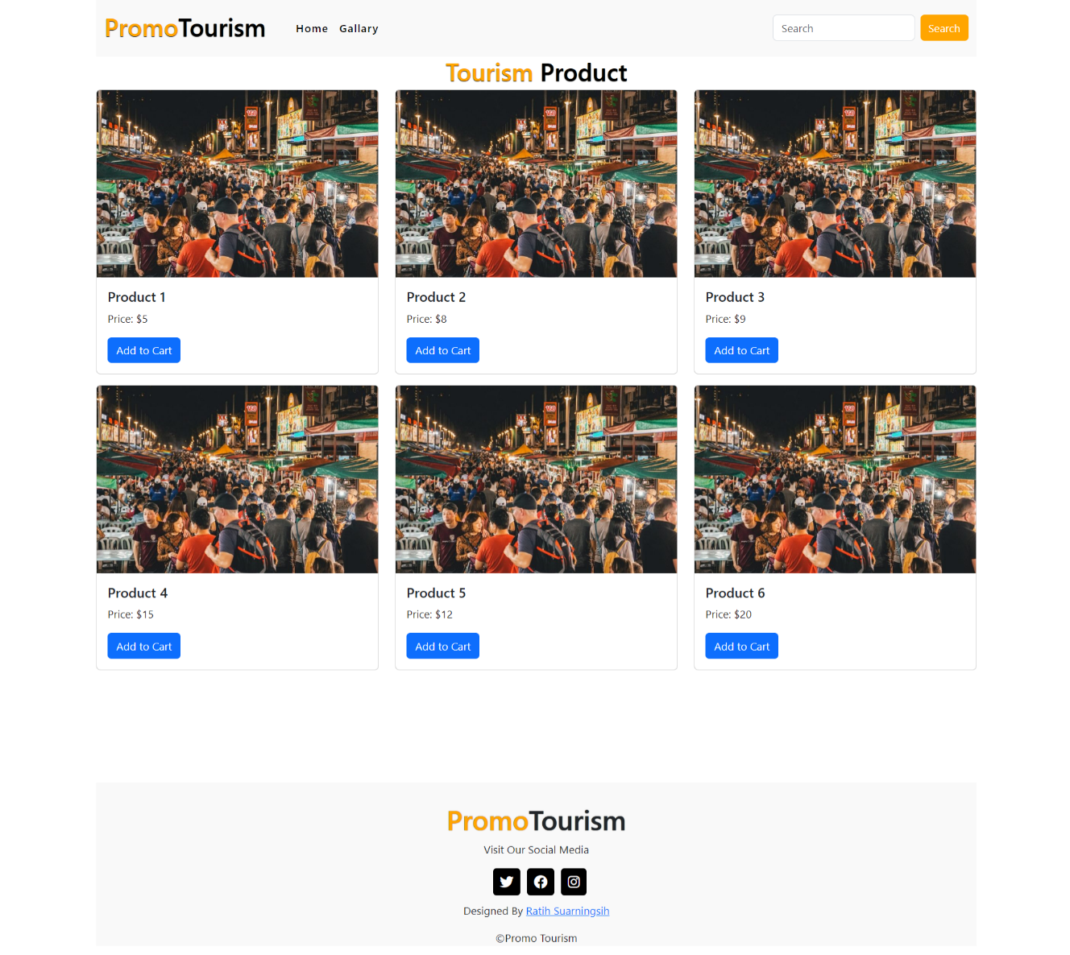

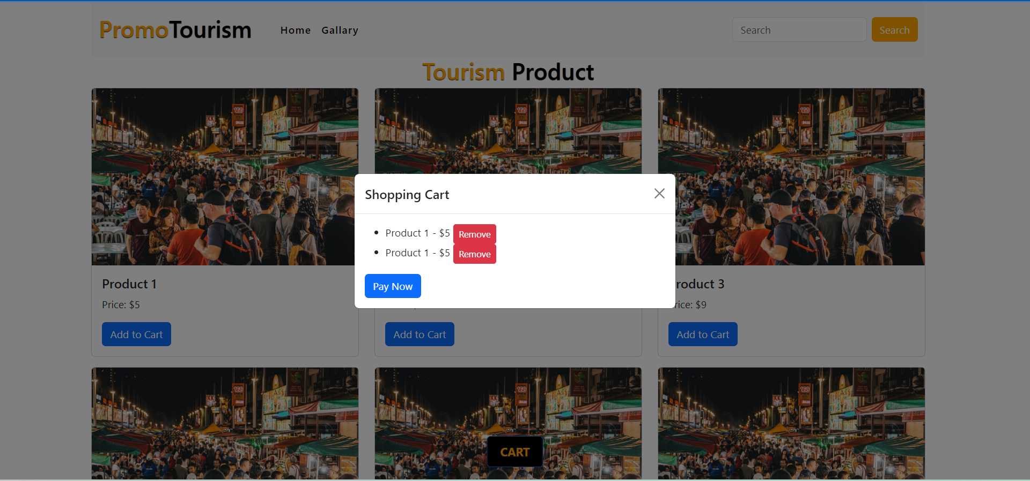

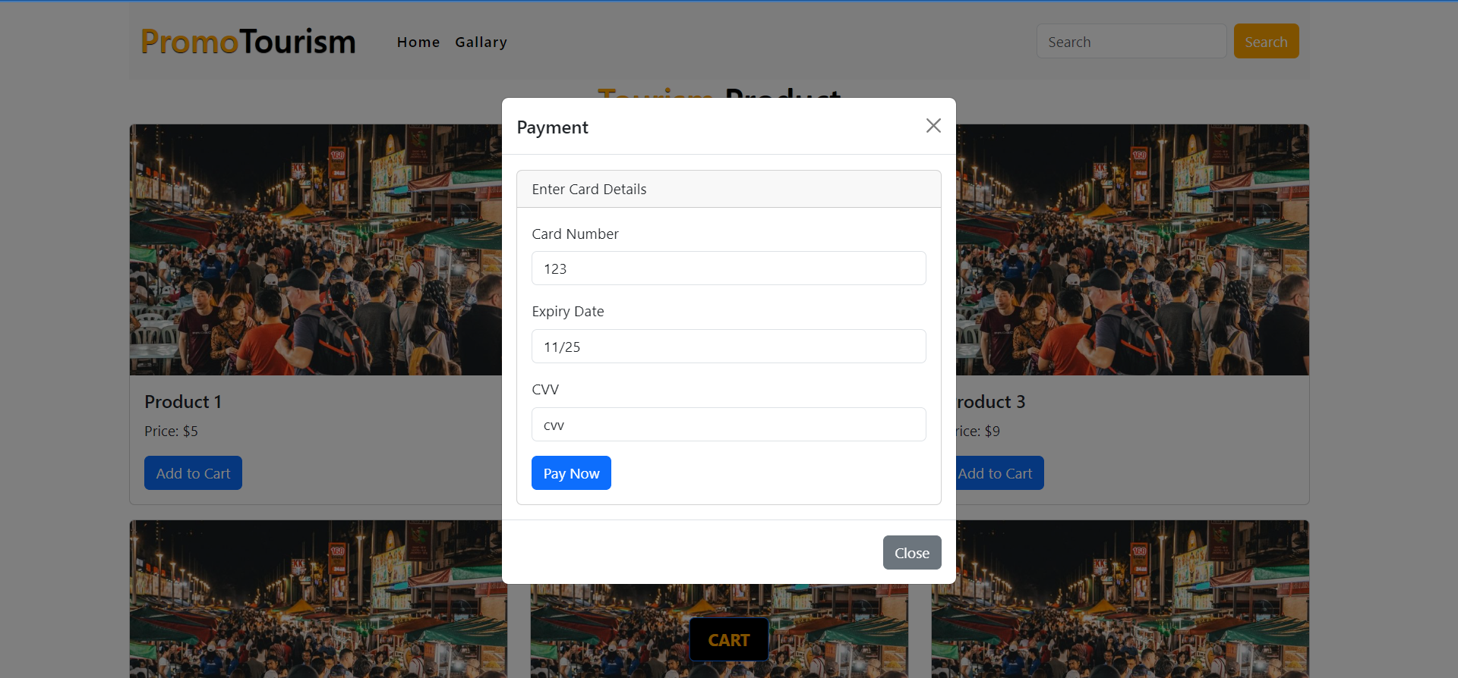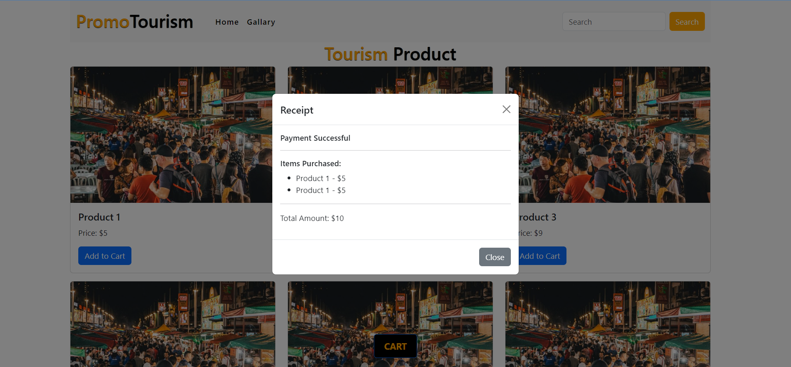

## Screenshot of Review Page

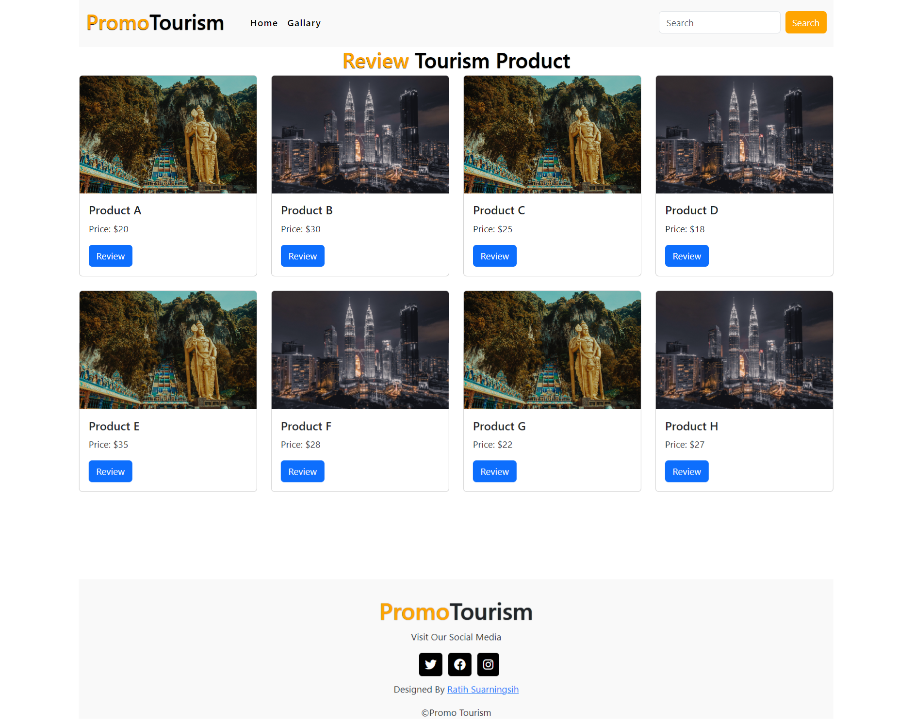After making a purchase, of course, the customer is able to carry out a review. The customer selects the product to be reviewed and then clicks the review button, after that the customer gives a rating and comment and then submits. Reviews will be stored on each product card, and products that have been reviewed cannot be reviewed again

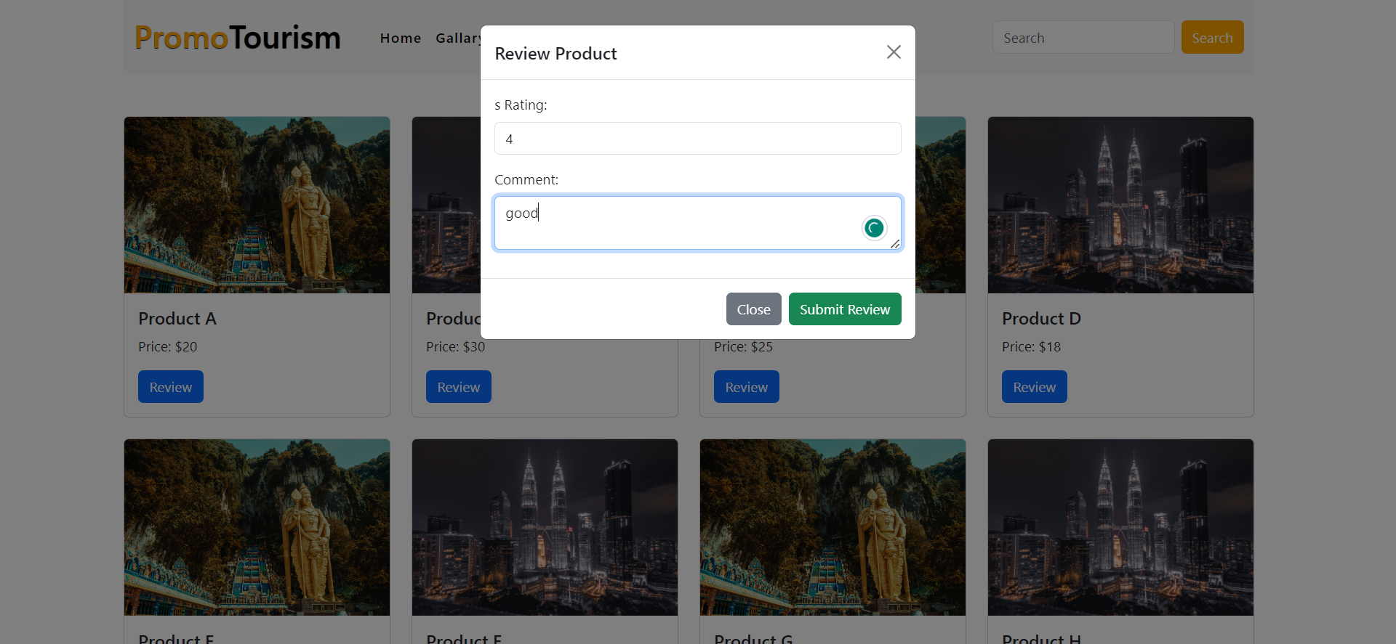

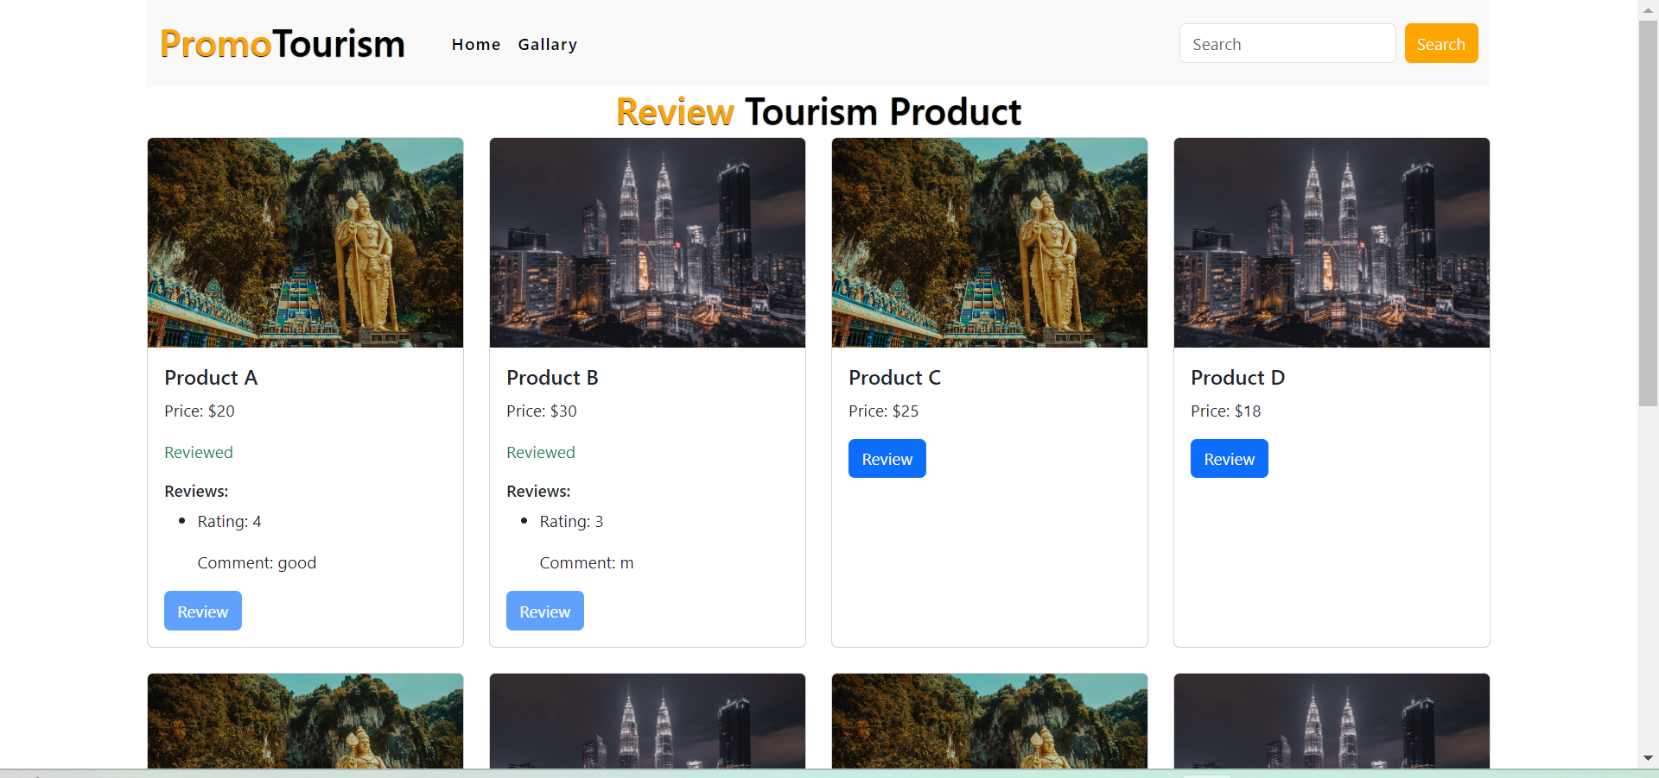

## Screenshot of Gallery Page

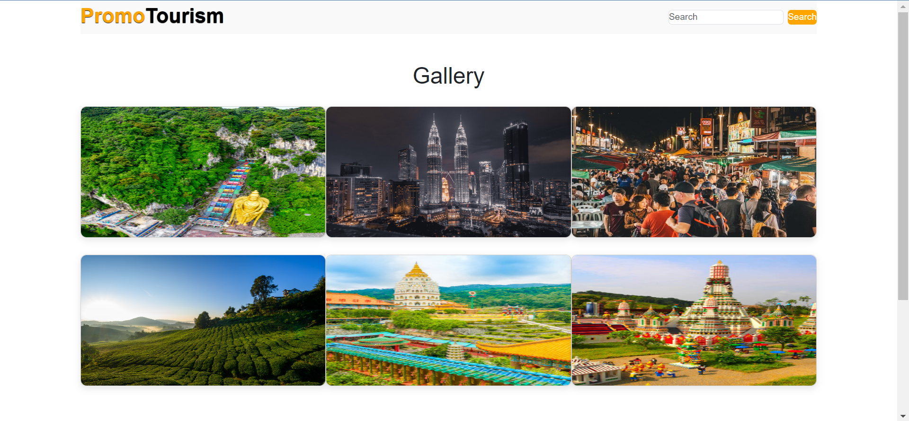This gallery page displays a preview of the tourist destinations offered by the Promo Tourism website

## Screenshot of register merchant page

This page allows users to register to become a merchant, the user must input the requested details and upload the required documents

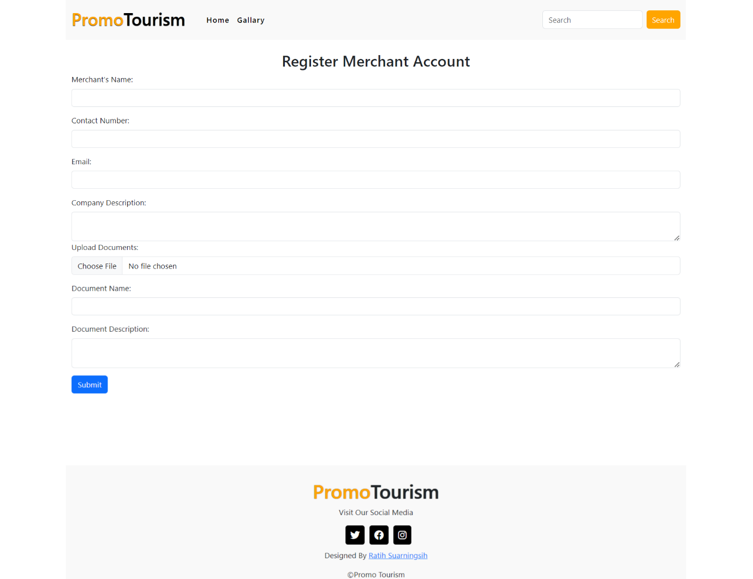

BIT306 Assignment 1 Marking Criteria

Average HTML tags and elements

|  |  |  |  |  |  |
| --- | --- | --- | --- | --- | --- |
| CLO assessed | Topic | | | | Awarded  Marks |
|
| CLO3: Develop responsive and dynamic web applications using current technologies | Overall look of the web application (10 marks) | | | |  |
| Developing - Little artistic merit, | Average Artistic flair and good | | Excellent - Well designed appealing site using CSS layout with complete website requirements. (7-10) |  |
| header image, footer floats design look. Contents in the website | | |  |
| correctly under content, CSS menu well arranged. (4-6)  correctly placed. (0-3) | | |  |
| CLO3: Develop responsive | Appropriate use of HTML elements (15 marks) | | | |  |
|  |  |
|  |  |  | |  |  |
|  |  |  | |  |  |
|  |  |  | |  |  |
|  |  | are incorporated properly with  heading, hyperlinks and lists (6-10) | | (average) but more relevant HTML  elements included to develop complete website requirements. (11-  15) |  |
| CLO3: Develop responsive and dynamic web applications using current technologies | Implementation of JavaScript Framework | | Angular & relevant libraries/frameworks (40 marks) | |  |
|  |  | | Excellent As previous level |  |
| Developing Minimal and Average Angular components, | | | (average) with complete |  |
| appropriate usage of Angular templates, directives and binding are  components (0-12) functionalities of web application. Use of appropriate libraries and  frameworks (13-25) | | | functionalities listed in Section C using Angular component correctly. Use of appropriate libraries and frameworks effectively to enhance the dynamic of a website (26-40) |  |

Excellent As previous level

incorporated properly to form basic

CLO2: Evaluate the

|  |  |  |  |  |
| --- | --- | --- | --- | --- |
|  | Report (25 marks) & Presentation (10 marks) | | |  |
| applications of different Developing Proper formatting | | Average As previous level | Excellent As previous level |  |
| libraries, frameworks and of report with most of the  technologies in creating a requirements included. Relevant web application web technologies listed. (0-8) | | (developing) with complete screenshot  of websites and its corresponding coding with description. Complete web technologies listed with explanation on | (average) with discussion on web  technologies implementation using literature support in the project. Comprehensive evaluation on |  |
|  | | the applicability (7 15) | technologies used in the web  development. Appropriate APA |  |
|  | |  | referencing in report. (16 25) |  |
| CLO3: Develop responsive Developing Lack of | |  | Excellent Complete |  |
| and dynamic web understanding in the development | | Average Showed a good | understanding in the development |  |
| applications using current of the system, presentation was technologies brief and poorly structured. (0-3) | | understanding in the development of  the system, content is relevant and organized. (4-6) | of the system, content is  comprehensive and clearly structured. (7-10) |  |
| Total | | | |  |
| Late Submission Penalty (-5 marks per day) | | | |  |
| TOTAL MARKS OUT OF 100 | | | |  |